Annex 1

2025年武汉国际创意设计大赛（金黄鹤奖）
平行方案征集题目
2025 Wuhan International Creative Design Competition
(Golden Yellow Crane Award) Competition Topics
基于“宜居、宜业、宜游”三大底层需求，倡导“小切口、微干预、可落地”的柔性设计理念，紧密对接各区重点实施项目，共设置7组平行方案征集。
Based on the three fundamental needs of a city that is livable, workable, and enjoyable, this competition promotes a flexible design philosophy centered on "small interventions, gentle adjustments, and practical implementation." The competition closely aligns with key projects in various districts, setting up a total of seven parallel design topics.

（一）南岸嘴“C位”观景点创意方案征集
(1) Creative Schemes for the "Center" Viewpoint at Nan'an Zui
1、设计范围
1. Scope of Solicitation
设计范围为南岸嘴公园整体区域，南岸嘴公园面积约13.2公顷。
The scope of solicitation covers the entire area of Nan'an Zui Park, with an area of approximately 13.2 hectares.
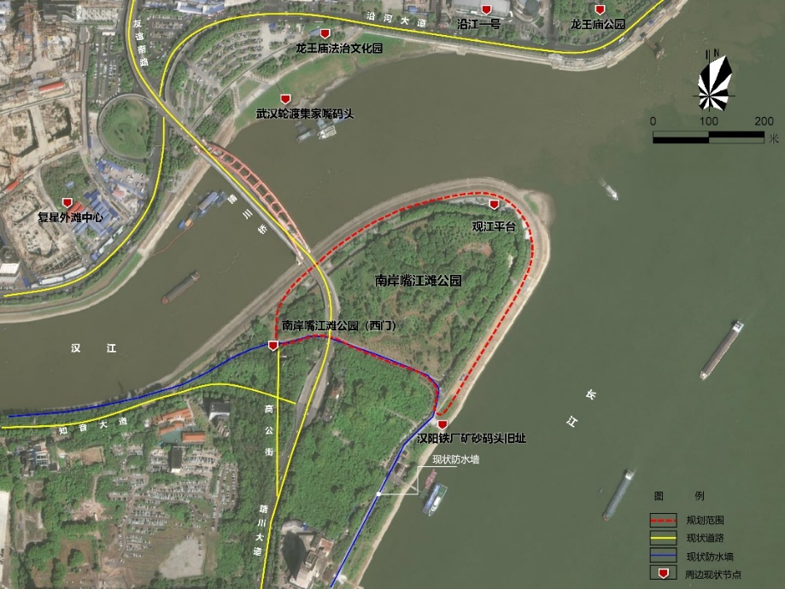
设计范围示意图 Schematic Diagram of the Scope of Solicitation
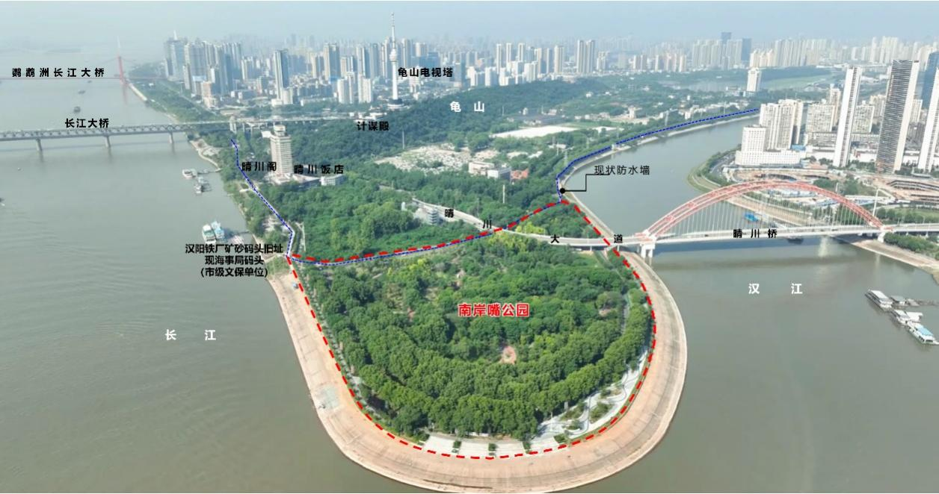南岸嘴公园现状航拍图 Aerial Photos of the Current Status of Nan'an Zui Park
2、现状痛点
2. Current Challenges
（1）核心主题不明，无法形成鲜明的品牌形象和游客记忆点。
（2）人气活力不旺，难以形成稳定的客流和社交氛围。
（3）核心配套设施缺乏，难以获得与场地特质相匹配的视觉震撼和记忆锚点。
a. Unclear core theme, failing to form a distinct brand image and memorable points for tourists.
b. Insufficient popularity and vitality, making it difficult to build a stable tourist flow and positive social atmosphere.
c. Lack of core supporting facilities, resulting in the inability to create visual impact and memory anchors that match the site's characteristics.
3、工作内容
3. Solicitation Content
（1）南岸嘴公园未来整体打造的畅想。通过深入分析南岸嘴的区位和景观优势，研判其在武汉市两江四岸及城市游憩路径中承载的功能，提出强化南岸嘴公园主题定位、补充合适功能和设施等方面的建议。可以是规划一条游玩、观景的路径、策划一场文化主题citywalk活动、设计一个突显地域文化的文创形象或主题IP等方式。
a. Vision for the overall future development of Nan'an Zui Park. Through in-depth analysis of Nan'an Zui's location and landscape advantages, assess its functional role in the "four banks of two rivers" area of Wuhan and urban recreational routes, and put forward suggestions on strengthening the thematic positioning of Nan'an Zui Park and supplementing appropriate functions and facilities. This can be realized by planning a sightseeing and viewing route, organizing a cultural-themed citywalk activity, or designing a cultural and creative image or thematic IP that highlights regional culture.
（2）南岸嘴公园空间品质提升。开展南岸嘴公园景观提升设计，可以是公园内绿化景观提升、可以是公园入口可视化提升、可以是标识系统的设计、可以是活动设施整体布局方案、可以是桥下空间利用的创意。
b. Improvement of the spatial quality of Nan'an Zui Park. Conduct landscape enhancement design for Nan'an Zui Park, which may include upgrading the green landscape within the park, enhancing the visibility of the park entrance, designing the sign system, formulating the overall layout plan for activity facilities, or developing ideas for the utilization of under-bridge spaces.
（3）“C位”观景点创意方案设计。在南岸嘴公园内找到观看“两江交汇、龟蛇锁江”盛景的C位观景点，开展微景观设计，如观江眺望点、互动体验装置、夜景标志、艺术取景框等。
c. Creative scheme design for the "Center" viewpoint. Identify the center viewpoint within Nan'an Zui Park to overlook the grand scene of "the confluence of two rivers and the locking of the river by Guishan and Sheshan", and carry out micro-landscape design, such as river-viewing platforms, interactive experience installations, nightscape landmarks, and artistic photo frames.

（二）平和打包厂片游线组织及空间提升方案
（2）Scheme for Tour Route Organization and Spatial Improvement of Pinghe Packaging Factory Area
1、设计范围
1. Scope of Solicitation
设计范围：以平和打包厂为核心，东至洞庭街、西至鄱阳街、北至天津路、南至青岛路，用地面积约为4公顷。
With Pinghe Packaging Factory as the core, the scope of solicitation extends east to Dongting Street, west to Poyang Street, north to Tianjin Road, and south to Qingdao Road, covering an area of approximately 4 hectares.
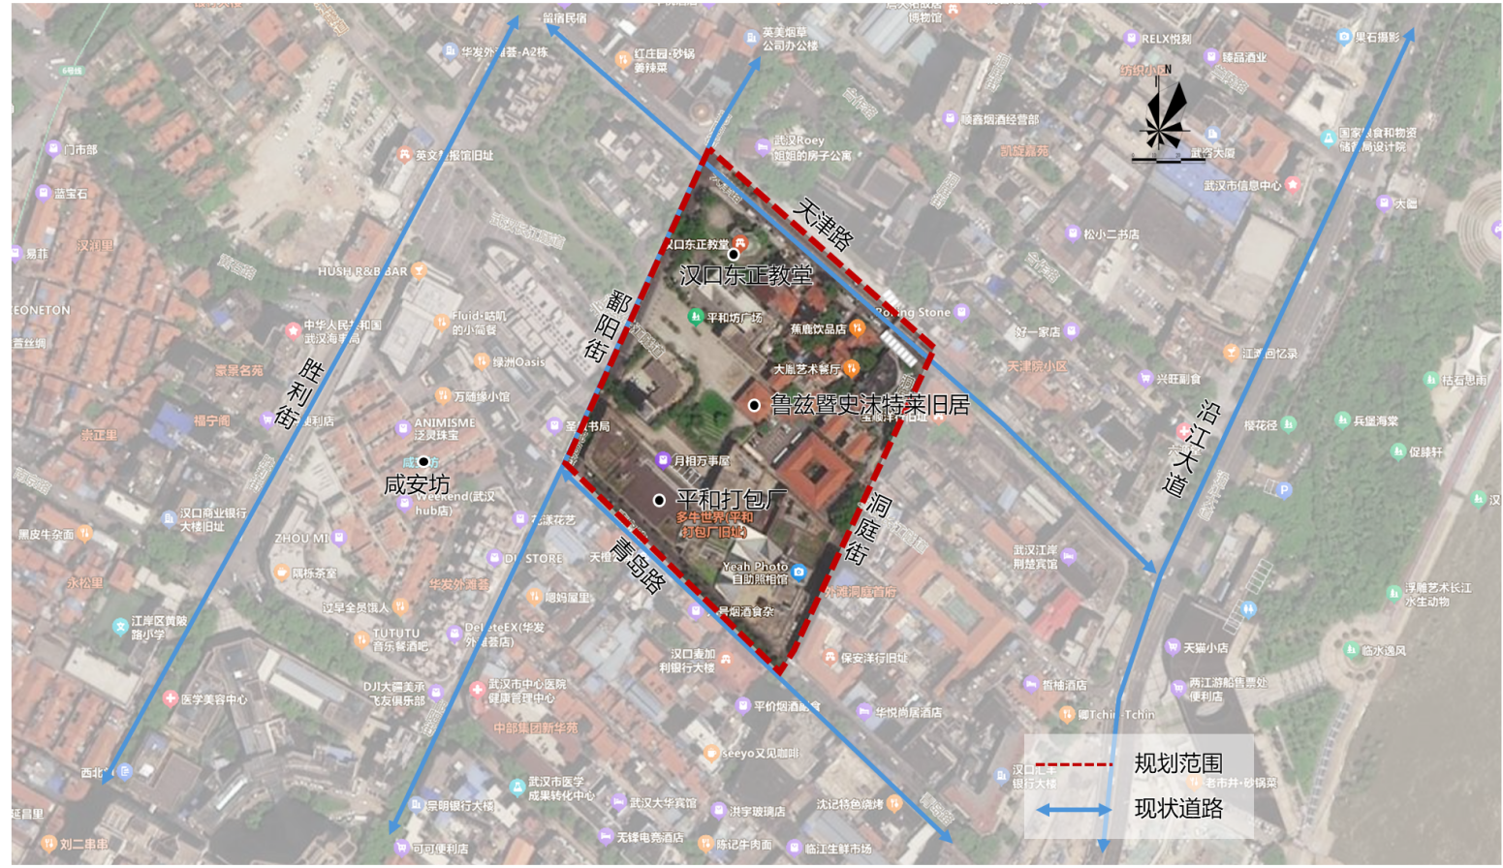
设计范围示意图Schematic Diagram of the Scope of Solicitation
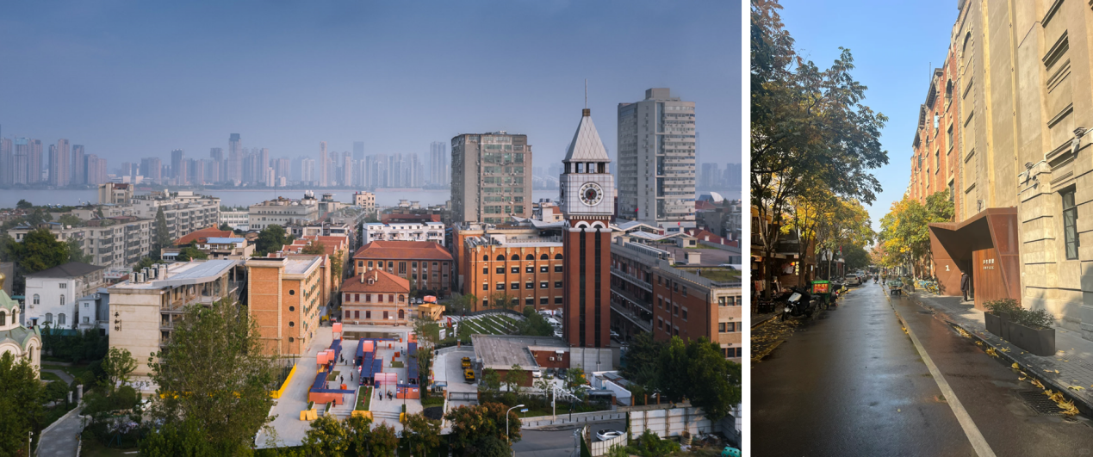
现状照片（平和坊、平和打包厂）Current Status Photos (Pinghe Fang and Pinghe Packaging Factory)
2、现状痛点
2. Current Challenges
（1）鲁兹暨史沫特莱旧居、汉口东正教堂等历史建筑活化利用不足，未联合形成具有影响力的IP。
a. Insufficient activation and utilization of historical buildings, such as the former residences of Luzhi and Shi Motailai, and Hankou Orthodox Church, leading to failure in forming an influential IP through integration.
（2）缺乏步行导引，与咸安坊等临近文旅资源的交通指引不足，游客难以便捷地辨别方向与目的地。
b. Lack of pedestrian guidance and inadequate traffic signs connecting to nearby cultural and tourism resources (e.g., Xian'an Fang), making it hard for tourists to identify directions and destinations conveniently.
（3）平和坊广场利用低效，缺乏配套设施和文旅活动。
c. Inefficient use of Pinghe Fang Square, with a shortage of supporting facilities and cultural-tourism activities.
3、工作内容
3. Solicitation Content
（1）闲置历史建筑资源挖潜盘整和文旅功能策划。识别片区可利用的建筑资源，合理植入新业态，整体提升片区活力。
a. Exploration, reorganization of idle historical building resources and planning of cultural-tourism functions. Identify available building resources in the area, reasonably introduce new business formats, and comprehensively enhance the vitality of the area.
（2）片区游览标识系统设计。设计串联平和打包厂、咸安坊、美术馆、江滩等文旅热点的步行导引系统（包括地面标识、景观小品、数字导览等）。
b. Design of the tourist sign system in the area. Develop a pedestrian guidance system (including ground signs, landscape features, and digital guides) that connects cultural and tourism hotspots such as Pinghe Packaging Factory, Xian'an Fang, Art Museum, and River Beach.
（3）平和坊广场空间微改造。增设配套服务设施、打卡设施和景观小品，提升人气。
c. Micro-renovation of the space of Pinghe Fang Square. Add supporting service facilities, check-in facilities, and landscape features to boost popularity.

（三）巴公房子片游赏空间提升方案
(3) Scheme for the Improvement of Tourist Spaces in Banov’s House Area
1、设计范围
1. Scope of Solicitation
设计范围：以巴公房子为核心，扩大至洞庭街、兰陵路、珞珈山街、黎黄陂路等周边道路的第一层建筑界面，用地面积约为3.5公顷。
With Banov’s House as the core, the scope of solicitation expands to the first-floor building interface of surrounding roads, including Dongting Street, Lanling Road, Luojiashan Street, and Lihuangpi Road, covering an area of approximately 3.5 hectares.
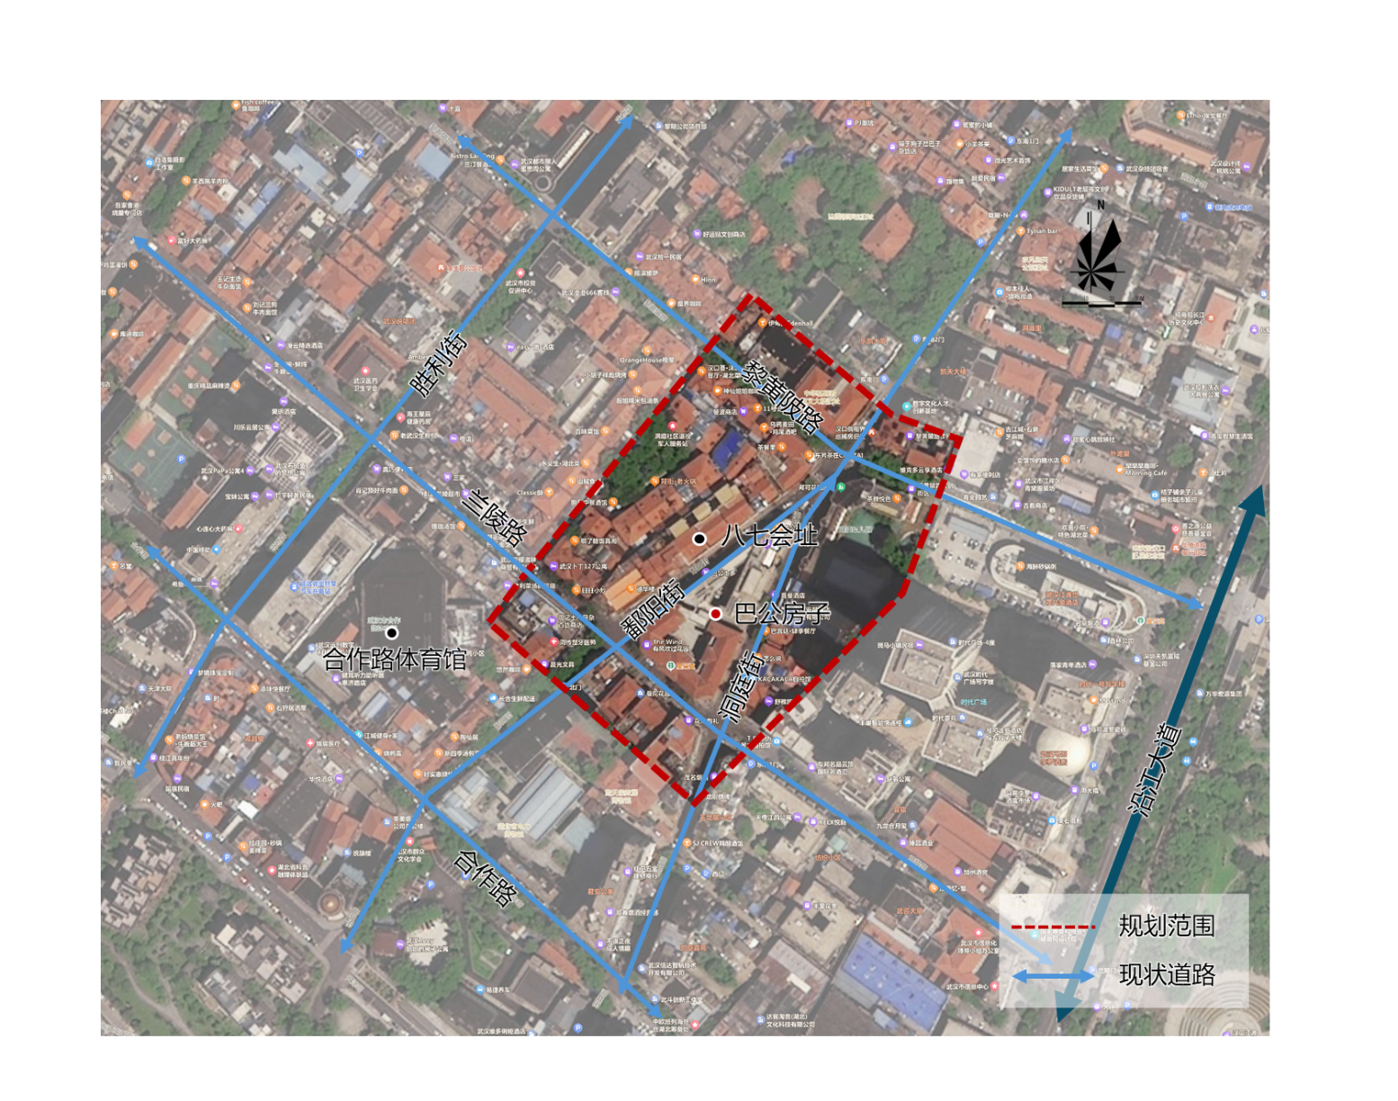
设计范围示意图 Schematic Diagram of the Scope of Solicitation
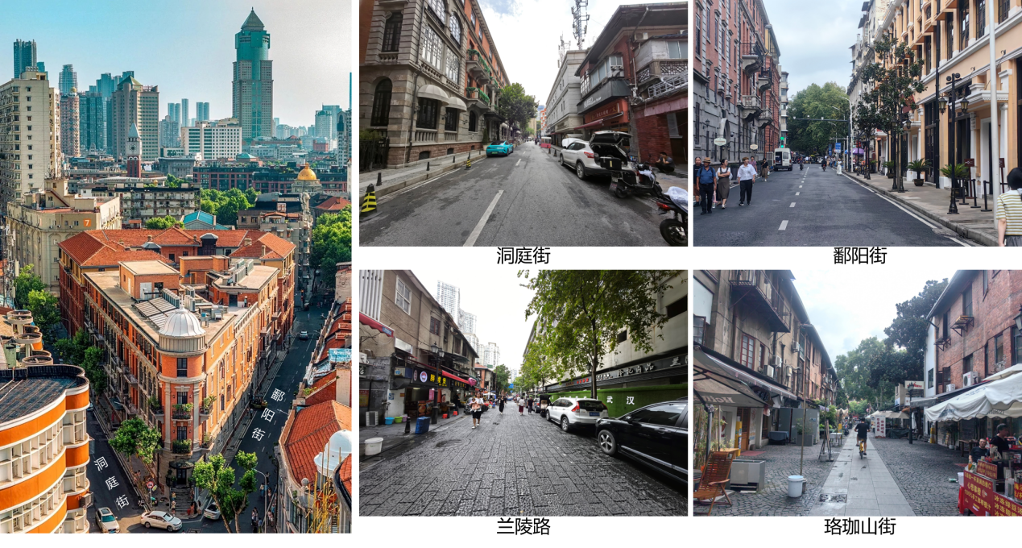
现状照片（巴公房子及周边道路）Current Status Photos (Banov’s House and Surrounding Roads)
2、现状痛点
2. Current Challenges
（1）巴公房子打卡点、鄱阳街、洞庭街人车混行、体验较差，且存在安全隐患。
a. Mixed traffic of pedestrians and vehicles at the Bagongfang check-in point, Poyang Street, and Dongting Street, resulting in poor user experience and potential safety risks.
（2）黎黄陂路、珞珈山街外摆占道经营，环境卫生杂乱；共享单车停放混乱无序、休憩座椅缺乏。
b. Roadside vending occupies road space on Lihuangpi Road and Luojiashan Street, causing messy environmental sanitation; shared bicycles are parked in disorder, and there is a lack of resting seats.
（3）个别历史建筑尚未打开围墙，空间封闭，有待活化利用。
c. The walls of some historical buildings remain unopened, leading to closed spaces that require activation and utilization.
（4）网红IP流量未充分转换，片区旅游标识不清晰，影响辨识度和游客体验；个别商铺招牌不协调，视觉效果差。
d. The traffic from Internet-famous IPs has not been fully converted; tourism signs in the area are unclear, affecting recognition and tourist experience; signs of some shops are inconsistent, resulting in poor visual effects.
3、工作内容
3. Solicitation Content
（1）巴公房子打卡点空间设计，洞庭街、鄱阳街街道设计（含标识系统）。针对巴公房子转角打卡点进行空间设计；优化洞庭街、鄱阳街道路断面，提升步行空间体验；提出人行和车行交通组织方案。优化标识系统，实现与周边景点的有效串联。
a. Spatial design of the Bagongfang check-in point and street design of Dongting Street and Poyang Street (including the sign system). Conduct spatial design for the corner check-in point of Bagongfang; optimize the road sections of Dongting Street and Poyang Street to improve the pedestrian space experience; put forward a traffic organization plan for pedestrians and vehicles. Optimize the sign system to achieve effective connection with surrounding scenic spots.
（2）黎黄陂路、珞珈山街微型公共空间设计。结合游憩需求增设公共座椅、布局自行车停靠点，提升环境卫生设施。
b. Design of micro-public spaces on Lihuangpi Road and Luojiashan Street. Add public seats and arrange bicycle parking spots according to recreational needs, and upgrade environmental sanitation facilities.
（3）历史建筑及公共空间微改造。识别有潜力活化利用的历史建筑及其院落，策划相应功能，开展微改造设计。
c. Micro-renovation of historical buildings and public spaces. Identify historical buildings and their courtyards with potential for activation and utilization, plan corresponding functions, and carry out micro-renovation design.
（4）制定业态提升方案，明确业态主题与正负面清单。基于片区现状业态分布，提出应调整、优化、植入的业态提升方案。
d. Formulate a business format improvement plan and clarify the thematic orientation and positive/negative lists for business formats. Based on the current distribution of business formats in the area, propose a business format improvement plan involving adjustment, optimization, and introduction of new formats.

（四）延庆里空间利用及功能策划方案征集
(4) Schemes for Space Utilization and Functional Planning of Yanqingli
1、设计范围
1. Scope of Solicitation
东临胜利街，南临二曜小路，西临中山大道，北临三阳路，总面积约0.96公顷。
It is adjacent to Shengli Street in the east, Eryao Xiaolu in the south, Zhongshan Avenue in the west, and Sanyang Road in the north, with a total area of approximately 0.96 hectares.
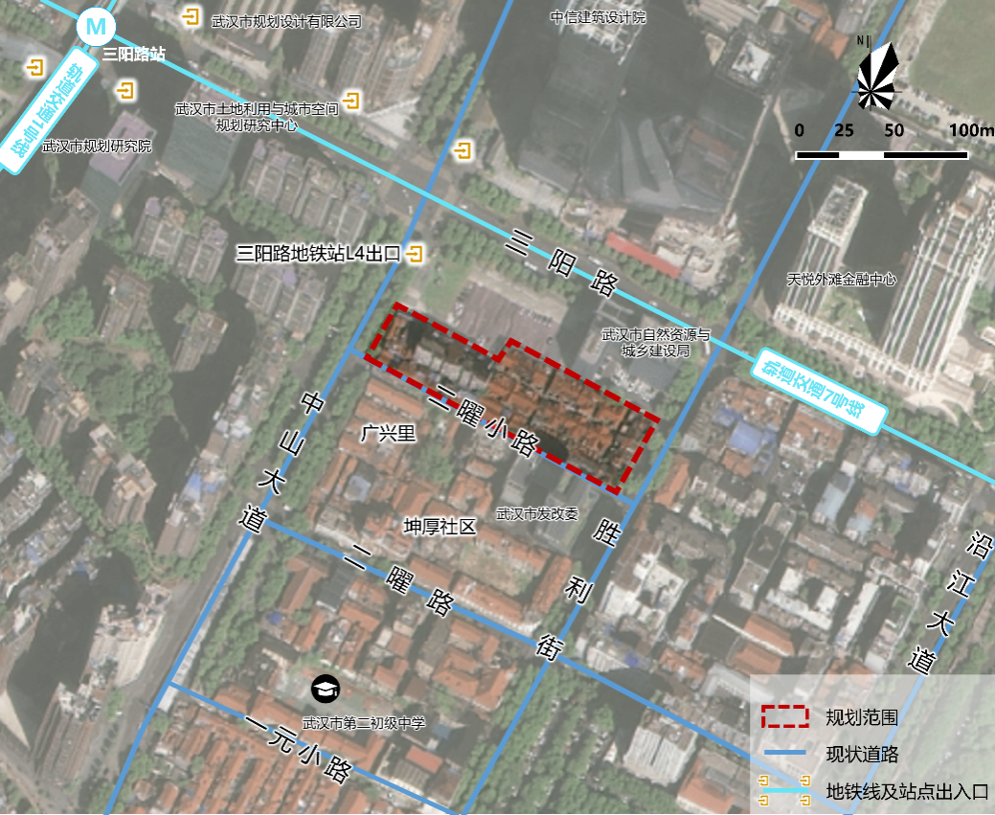
设计范围示意图Schematic Diagram of the Scope of Solicitation
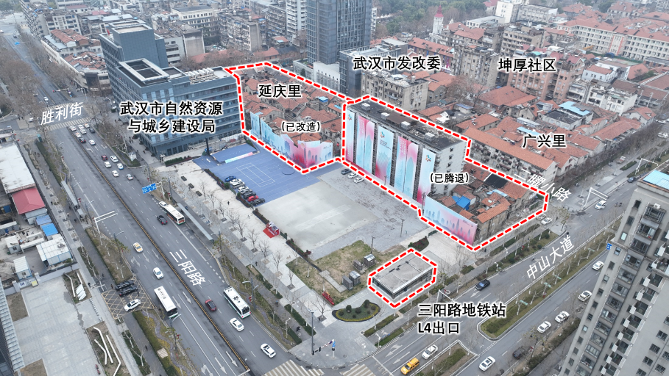
现状建筑航拍照片 Aerial Photos of Current Buildings
2、现状痛点
2. Current Challenges
（1）街区功能业态待提升，创意设计特色不显。
a. The functional business formats of the block need to be upgraded, and the characteristics of creative design are not prominent.
（2）中山大道侧部分建筑待改造，闲置空间未利用。
b. Some buildings on the Zhongshan Avenue side require renovation, and idle spaces have not been put into use.
（3）地块内部交通游线待优化，地铁出入口目的性不足。
c. The internal traffic and tourist routes of the plot need optimization, and the subway entrances/exits lack clear positioning.
3、工作内容
3. Solicitation Content
（1）怎样更设计？策划符合延庆里运营和发展的功能和业态，如创意工坊、艺术商业、休闲消费等，以及更多适合该片区发展的新业态。
a. How to optimize the design? Plan functions and business formats that align with the operation and development of Yanqingli, such as creative workshops, art commerce, and leisure consumption, as well as more new business formats suitable for the development of this area.
（2）怎样更好玩？针对沿中山大道地块以及腾退建筑空间提出创意设计和再利用方案。
b. How to enhance the appeal? Propose creative design and reuse schemes for the plots along Zhongshan Avenue and the vacated building spaces.
（3）怎样更好逛？结合地铁出入口和延庆里艺术街区特色功能，策划交通及游览路线、突出历史风貌的打卡路径等。
c. How to improve sightseeing accessibility? Combine the subway entrances/exits and the characteristic functions of Yanqingli Art Block to plan traffic and tourist routes, as well as check-in routes that highlight the historical style.

（五）山海关路片街道空间与文化标识重塑方案征集
(5) Schemes for the Remodeling of Street Space and Cultural Signs in Shanhaiguan Road Area
1、设计范围
1. Scope of Solicitation
山海关路片北至沈阳路、南至陈怀民路、东至胜利街、西至中山大道，用地面积约3公顷。
Shanhaiguan Road Area ranges from Shenyang Road in the north to Chenhuaimin Road in the south, from Shengli Street in the east to Zhongshan Avenue in the west, covering an area of approximately 3 hectares.
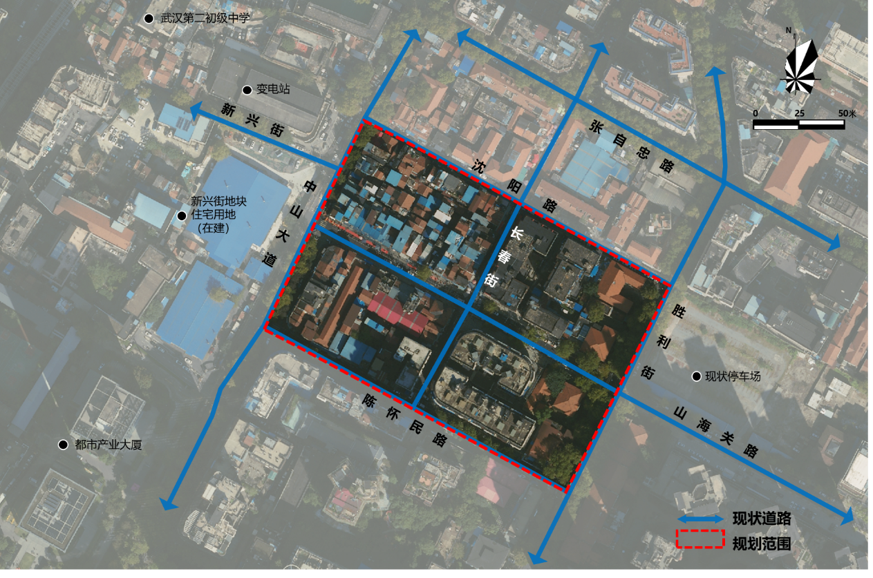
设计范围及周边影像图Image Map of the Scope of Solicitation and Surroundings
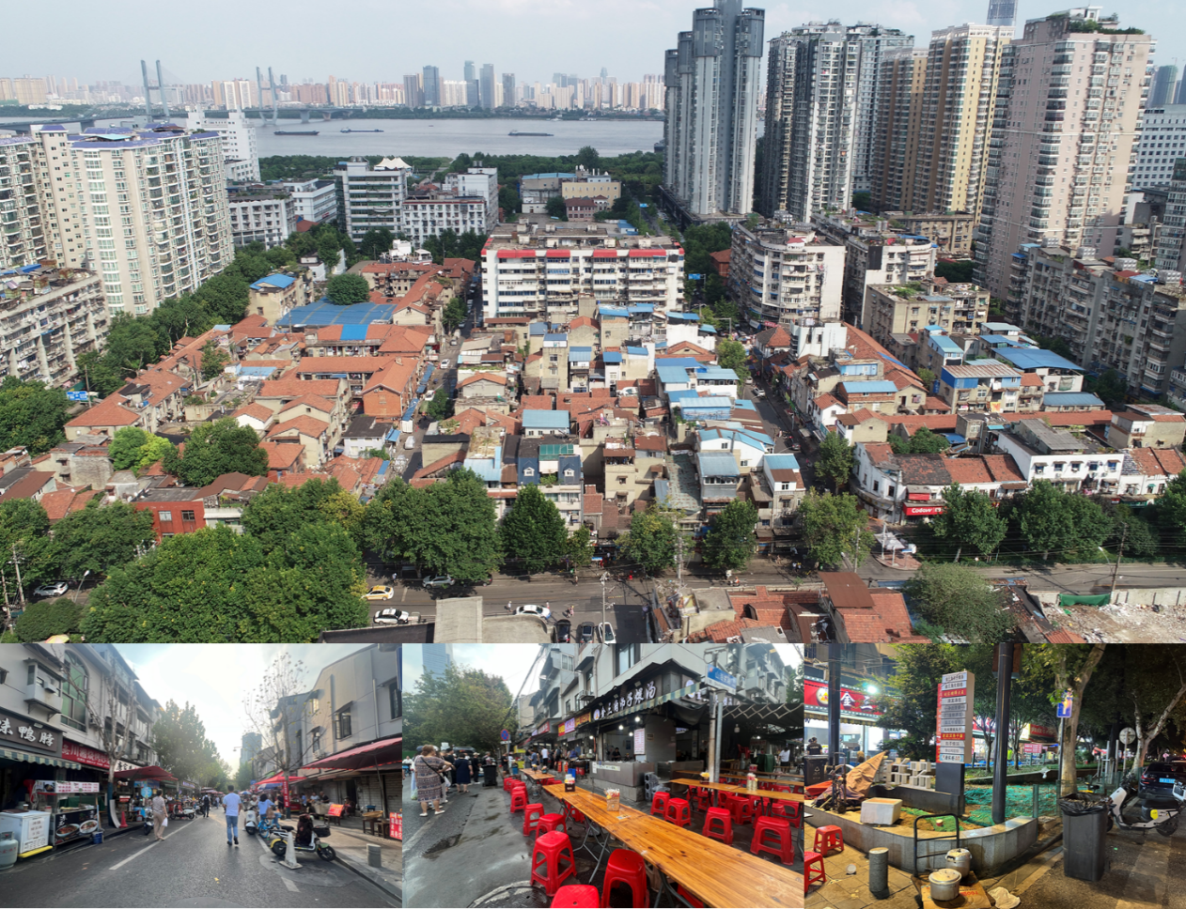
现状照片（航拍图及设计范围周边现状照片）Current Status Photos (Aerial Photos and Current Status Photos of the Surroundings of the Scope of Solicitation)
2、现状痛点
2. Current Challenges
（1）山海关路街道空间早晚市时段占道乱象频发。
a. Illegal road occupation frequently occurs in the street space of Shanhaiguan Road during morning and evening market hours.
（2）中山大道沿街绿地封闭，使用低效。
b. The green spaces along Zhongshan Avenue are closed off and used inefficiently.
（3）山海关路片缺乏统一、可识别的品牌形象。
c. The Shanhaiguan Road Area lacks a unified and recognizable brand image.
3、工作内容
3. Solicitation Content
（1）山海关路（中山大道-胜利街）街道空间早晚市时段使用方案。根据不同人群的使用需求，对山海关路早晚市商业店铺外摆区、慢行空间、车行空间、交通管理进行优化组织。
a. Scheme for the use of the street space of Shanhaiguan Road (from Zhongshan Avenue to Shengli Street) during morning and evening market hours. According to the usage needs of different groups, optimize the organization of roadside vending areas for commercial stores, slow-moving spaces, vehicle lanes, and traffic management on Shanhaiguan Road during morning and evening markets.
（2）沿中山大道低效绿地空间设计。以生态空间融合社区生活为理念，对现有绿地进行改造。
b. Design of inefficient green spaces along Zhongshan Avenue. Transform the existing green spaces based on the concept of integrating ecological spaces with community life.
（3）山海关路片标志标语征集。全面提升山海关路片区的品牌形象与文化影响力，精准传递其“历史底蕴”与“舌尖活力”交融的独特魅力。
c. Solicitation of symbolic slogans for the Shanhaiguan Road Area. Comprehensively enhance the brand image and cultural influence of the Shanhaiguan Road Area, and accurately convey its unique charm that combines "historical heritage" and "vitality of food culture".

（六）汉阳门花园片游赏体验升级创意方案
(6) Creative Scheme for the Upgrade of Tourist Experience in Hanyangmen Garden Area
1、设计范围
1. Scope of Solicitation
北至民主路、南至武珞路、东至武昌路、西至长江，用地面积约26公顷。
It ranges from Minzhu Road in the north to Wuluo Road in the south, from Wuchang Road in the east to the Yangtze River in the west, covering an area of approximately 26 hectares.
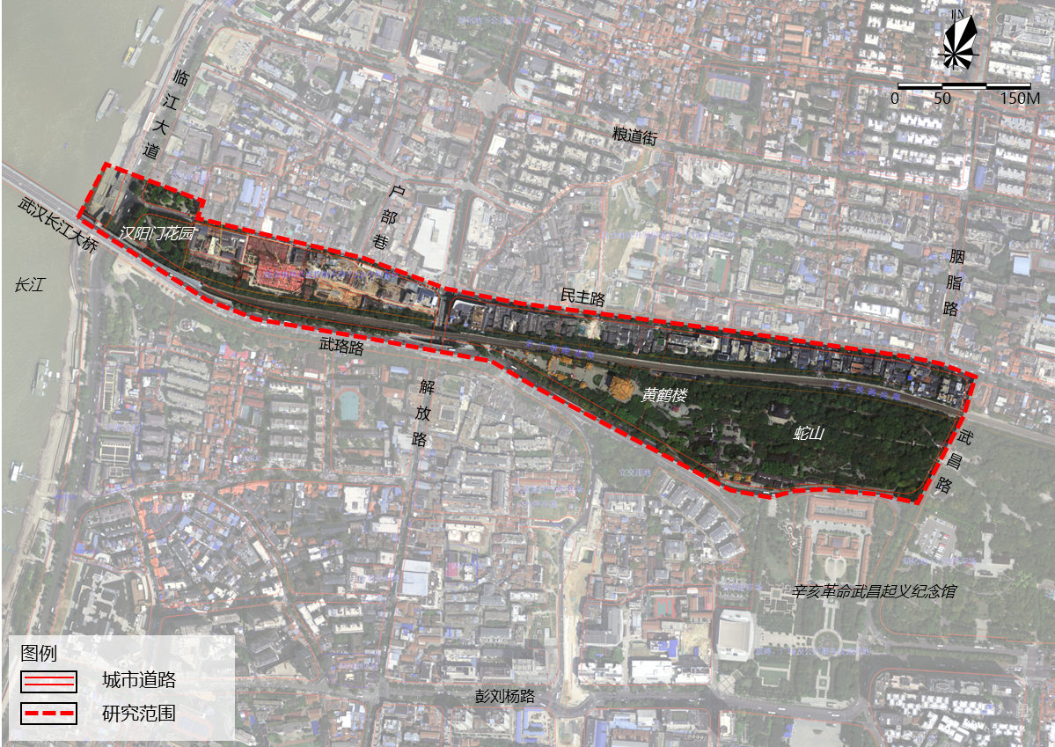
设计范围示意图 Schematic Diagram of the Scope of Solicitation
2、现状痛点
2. Current Challenges
（1）拥有长江大桥、武昌江滩、户部巷、斗级营、黄鹤楼等顶级旅游资源，有待系统性整合和价值释放。
a. It is home to top-tier tourism resources such as the Yangtze River Bridge, Wuchang River Beach, Hubu Lane, Doujiying, and Yellow Crane Tower, which require systematic integration to unlock their value.
（2）核心定位不清，品牌形象和游览导视特色性不强、体系不统一。
b. Unclear core positioning, with weak characteristics of the brand image and inconsistent systems for tourist guidance signs.
（3）城市漫步游线不显，景点资源和趣味空间有待挖掘和组织。
c. Urban walking routes are not distinct, and scenic resources and interesting spaces need to be explored and organized.
（4）国际性节事活动及品牌IP不够，难以支撑世界级文旅目的地。
d. Insufficient international festivals, events, and brand IPs, making it difficult to develop into a world-class cultural and tourism destination.
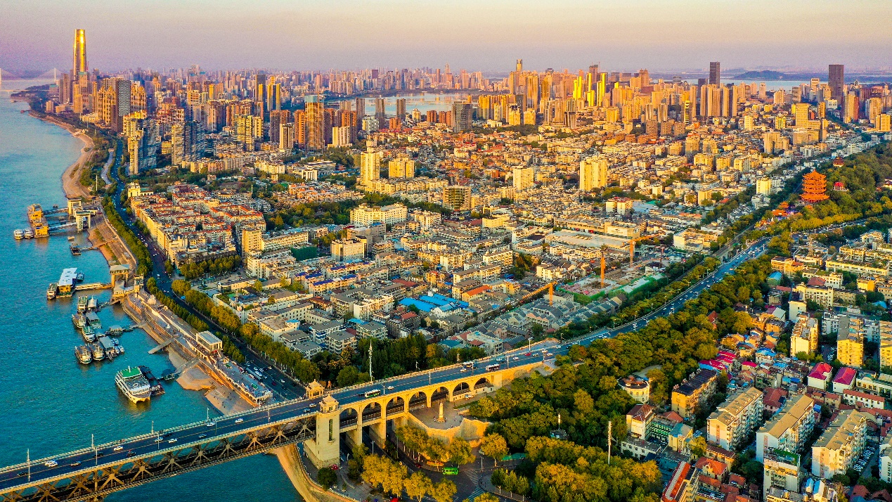
现状航拍图片 Current Status Aerial Photos
3、工作内容：
3. Solicitation Content
（1）汉阳门花园片区品牌形象及国际化游览导视系统设计。
a. Design of the brand image and international tourist guidance system for the Hanyangmen Garden Area.
（2）规划一条整合串联片区核心景点资源的城市漫步游线。
b. Plan an urban walking route that integrates and connects the core scenic resources in the area.
（3）策划黄鹤楼、长江大桥经典观景点，选取其一开展微景观设计。比如观楼-桥-江眺望点、互动体验装置、艺术取景框等。
c. Plan classic viewpoints for the Yellow Crane Tower and the Yangtze River Bridge, and select one to carry out micro-landscape design, such as viewing platforms for the "tower-bridge-river" scenery, interactive experience installations, and artistic photo frames.
（4）策划标志性体验项目及品牌节事活动，比如“桥头堡博物馆”“长江诗歌月”活动等。
d. Plan landmark experience projects and brand festivals/events, such as the "Bridgehead Museum" and the "Yangtze River Poetry Month" event.

（七）环黄鹤楼片观光打卡点创意方案征集
(7) Creative Schemes for Sightseeing Check-in Points in the Yellow Crane Tower Surrounding Area
1、设计范围
1. Scope of Solicitation
研究范围为粮道街、胭脂路、武昌路、彭刘杨路及长江所围合区域，总用地面积约147平方公里。
The research scope covers the area enclosed by Liangdao Street, Yanzhi Road, Wuchang Road, Pengliuyang Road, and the Yangtze River, with a total land area of approximately 147 square kilometers.
黄鹤楼红墙设计范围为粮道街、民主路及两条规划支路围合而成的经心书院片，用地面积约2.94公顷。
The scope of solicitation for the Yellow Crane Tower Red Wall covers the Jingxin Academy Area enclosed by Liangdao Street, Minzhu Road, and two planned branch roads, with a land area of approximately 2.94 hectares.
云朵粉墙设计范围为粉墙所在小游园及其相邻第一排建筑，用地面积约1公顷。
The scope of solicitation for the Yun Duo Pink Wall covers the small garden where the pink wall is located and the first row of adjacent buildings, with a land area of approximately 1 hectare.
先贤街片设计范围为武珞路南侧先贤街区，用地面积约0.81公顷。
The scope of solicitation for the Xianxian Street is located on the south side of Wuluo Road, covering an area of approximately 0.81 hectares.
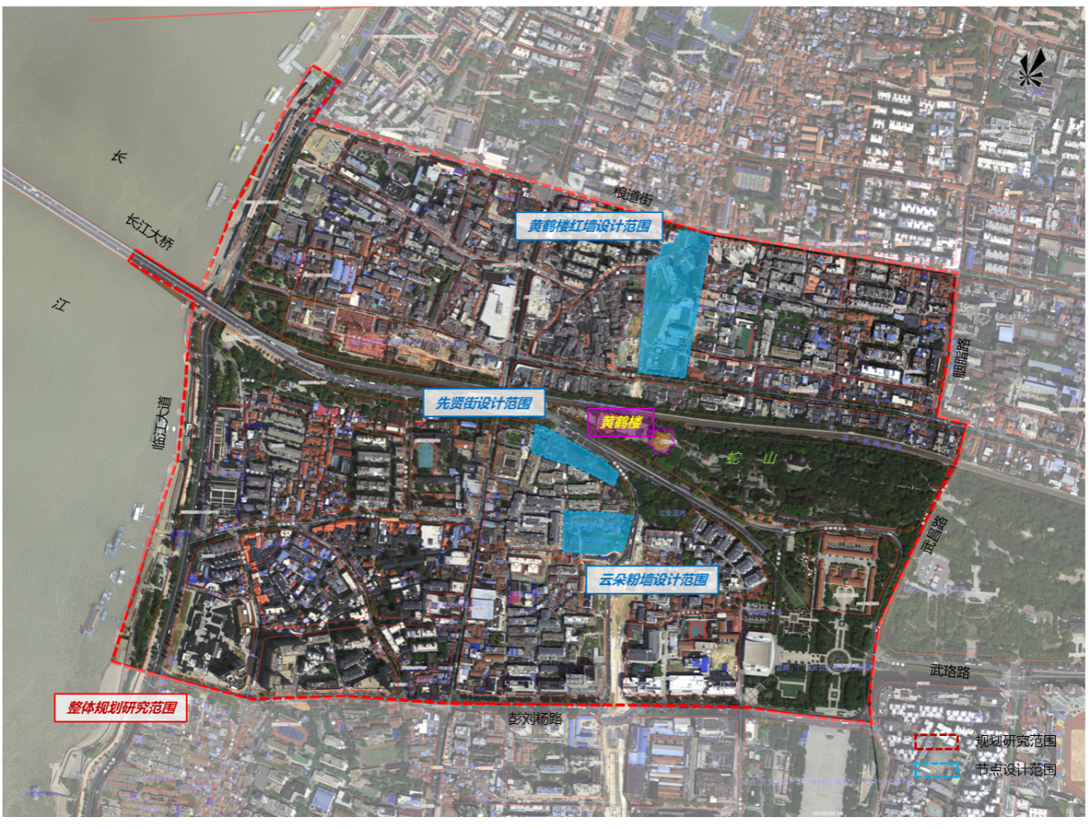
设计范围示意图Schematic Diagram of the Scope of Solicitation
2、现状痛点
2. Current Challenges
（1）黄鹤楼周边已自发形成若干“网红”打卡点，存在“有点无线、有珠无链”，交通、景观、服务等配套设施不足等问题。
a. Several self-formed "Internet-famous" check-in points around the Yellow Crane Tower face issues such as "having individual points but no connecting lines, having scattered highlights but no integrated system", and insufficient supporting facilities for transportation, landscape, and services.
（2）黄鹤楼红墙、云朵粉墙网红打卡点存在配套设施缺乏、体验单一问题。
b. The Internet-famous check-in points of the Yellow Crane Tower Red Wall and Yun Duo Pink Wall lack supporting facilities and offer a single-dimensional experience.
（3）先贤街区位核心，历史深厚，风貌独特，其价值特色有待彰显，功能活力有待提升。
c. The Xianxian Street Area has a core location, profound historical heritage, and a unique style, but its value and characteristics need to be highlighted, and its functional vitality needs to be enhanced.
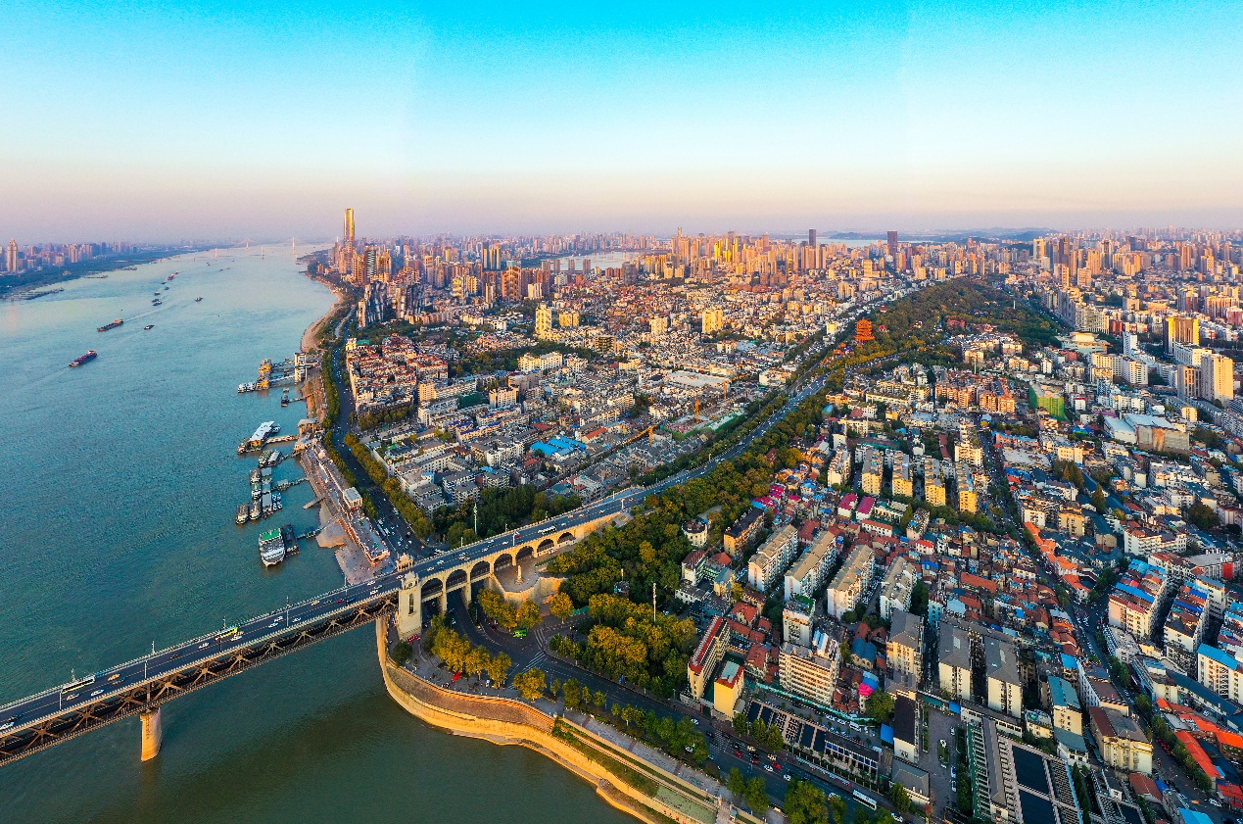
现状航拍图 Current Status Aerial Photos
3、工作内容
3. Solicitation Content
（1）构建黄鹤楼周边观光打卡点体系。系统评估黄鹤楼周边区域功能格局、经典旅游路径、停驻观景体系等，以此为基础提出黄鹤楼周边观光打卡空间布局结构，提出潜在优质观景点、互动点的选址与主题建议。
a. Construct a system of sightseeing check-in points around the Yellow Crane Tower. Conduct a systematic assessment of the functional layout, classic tourism routes, and stopover viewing system in the area around the Yellow Crane Tower. Based on this assessment, propose the spatial layout structure of the sightseeing check-in points around the Yellow Crane Tower, as well as suggestions on the location and theme of potential high-quality viewing points and interactive points.
（2）从黄鹤楼红墙、八卦井云朵粉墙、先贤街片区等三个点位中选择1个点位进行详细规划设计。紧扣各点位现状存在的问题，围绕任务书给出的设计要点，灵活确定规划成果内容。
b. Select one of the three sites—the Yellow Crane Tower Red Wall, the Bagua Well Yun Duo Pink Wall, and the Xianxian Street Area—for detailed planning and design. Closely address the existing challenges of each site, focus on the key design points specified in the task book, and flexibly determine the content of the planning results.

